AN1299 Demonstration ReadMe for the  
dsPICDEM™ LVMC Development Board with the dsPIC33CK256MP508 (MPLAB® X IDE)

1. Introduction

This document describes the setup requirements for running the Sensor-less FOC algorithm with a PLL Estimator using DC bus Current, which is referenced in AN1299 “Single-Shunt Three-Phase Current Reconstruction Algorithm for Sensorless FOC of a PMSM” using a dsPICDEM™ LVMC Development Board.

The demonstration is configured to run on the dsPICDEM™ LVMC Development Board in both Internal and External Op Amp configuration with the dsPIC33CK256MP508.

1. Suggested Demonstration Requirements
   1. Motor Control Application Firmware Required for the Demonstration

* AN1299_dsPIC33CK256MP508_EXT_INT_OPAMP_LVMC.zip

**Note:**

In this document, hereinafter this firmware package is referred as firmware**.**

* 1. Software Tools Used for Testing the firmware
* MPLAB® X IDE v5.20 or later
* MPLAB® XC16 Compiler v1.36b
* MPLAB® X IDE Plugin: X2C-Scope v1.2.3 or later

**Note:**

The software used for testing the firmware prior to release is listed above. It is recommended to use the version listed above or later versions for building the firmware.

* 1. Hardware Tools Required for the Demonstration
* dsPICDEM™ LVMC Development Board (DM----------)
* 24V Power Supply (AC002013)
* 24V 3-Phase Brushless DC Motor (AC300020)
* Microchip Programmer tool - MPLAB PICkit 4 In-Circuit Debugger (PG164140).

**Note:**

All items listed under this section Hardware Tools Required for the Demonstration are available at [microchip DIRECT](http://www.microchipdirect.com/).

1. Hardware Setup

This section describes hardware setup required for the demonstration. Motor phase current feedbacks needed by the firmware are amplified by the operational amplifiers.

If the amplifiers that are internal to the dsPIC33CK256MP508 are used, then that configuration is called internal amplifier configuration. If external amplifiers are used, then that configuration is called as external amplifier configuration.

1. Perform the following modifications based upon amplifier configuration. By default, Board is configured for Internal OP-AMP Configuration.
2. Connect the three phase wires from the motor to PHA, PHB, and PHC terminals of connector J14(there is no specific order), provided on the dsPICDEM™ LVMC Development Board.

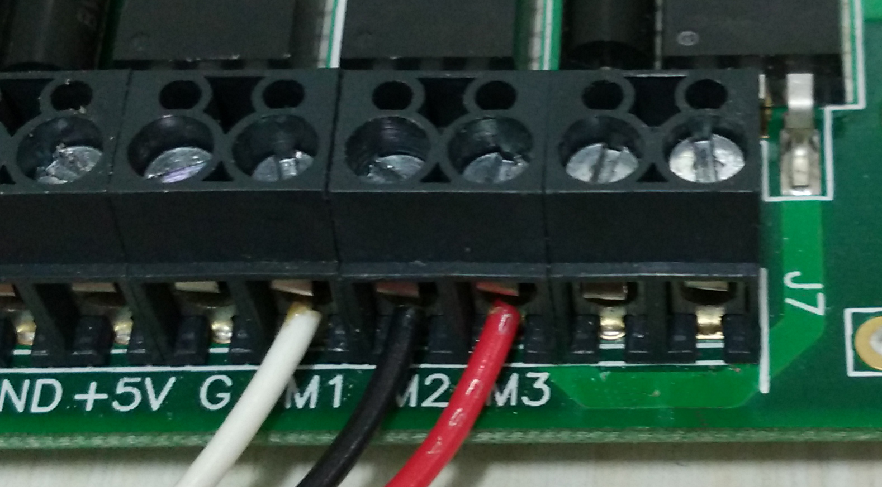

1. Plug in the 24V power supply to connector J1 or J2 provided on the dsPICDEM™ LVMC Development Board.



1. Connect the Microchip programmer/debugger MPLAB PICkit 4 In-Circuit Debugger to the Connector J10 of the dsPICDEM™ LVMC Development Board as shown below and to the Host PC used for programming the device. Ensure the arrows indicated on the board and PICkit 4 orient as shown in the picture.

|  |  |
| --- | --- |
|  |  |

Alternatively, the programmer/debugger can be connected to J20 using a micro-USB Connector.

1. Software Setup and Run
   1. Setup: MPLAB X IDE and MPLAB XC16 Compiler

Install MPLAB X IDE and MPLAB XC16 Compiler versions that support the device dsPIC33CK256MP508 and PKOBV4. The version of the MPLAB X IDE, MPLAB XC16 Compiler and X2C-Scope plug-in used for testing the firmware are mentioned in the section Motor Control Application Firmware Required for the Demonstration. To get help on

* MPLAB X IDE installation, refer [link](http://microchipdeveloper.com/mplabx:installation)
* MPLAB XC16 Compiler installation steps, refer [link](http://microchipdeveloper.com/xc16:installation)

If MPLAB IDE v8 or earlier is already installed on your computer, then run the MPLAB driver switcher (It is installed when MPLAB®X IDE is installed) to switch from MPLAB IDE v8 drivers to MPLAB X IDE drivers. If you have Windows 7 or 8, you must run MPLAB driver switcher in ‘Administrator Mode’. To run the Device Driver Switcher GUI application as administrator, right click on the executable (or desktop icon) and select ‘Run as Administrator’. For additional details refer MPLAB X IDE help topic *“Before You Begin: Install the USB Device Drivers (For Hardware Tools): USB Driver Installation for Windows Operating Systems”.*

* 1. Setup: X2C - SCOPE

X2C - SCOPE is a MPLAB X IDE plugin that allows a developer to interact with an application while the application program is running. X2C-Scope enables you to read, write, and plot global variables (for motor control) in real time. It communicates with the target using the UART. To use X2C, the plugin must be installed:

* In MPLAB X IDE, select Tools>Plugins and click on the **Available Plugins** tab.
* Select X2C - SCOPE plug-in by checking its check box, and then click **Install**.
* Look for tool X2C - SCOPE under Tools>Embedded.

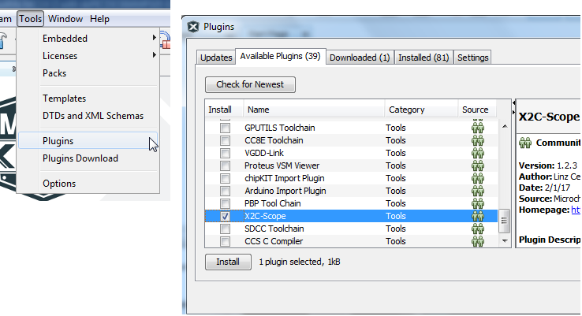

1. Basic Demonstration
   1. Firmware Description

The firmware version required for the demonstration is mentioned under the section Motor Control Application Firmware Required for the Demonstration.

This firmware is implemented to work on Microchip’s 16-bit Digital signal controller (dsPIC® DSC) dsPIC33CK256MP508**.** For more information, see the *dsPIC33CK256MP508 Family datasheet (DS70005349)*.

The Motor Control Demo application uses push button to start or stop the motor and potentiometer to vary speed of the motor.

This Motor Control Demo Application configures and uses peripherals like PWM, ADC, UART etc. required for implementing Sensor-less Field Oriented Control (FOC) of Permanent Magnet Synchronous Motor (PMSM) based on the motor control application AN1299 & AN1292.

For more details refer Microchip Application note AN1299 “Single-Shunt Three-Phase Current Reconstruction Algorithm for Sensorless FOC of a PMSM” and AN1292 “Sensorless Field Oriented Control(FOC) for a Permanent Magnet Synchronous Motor(PMSM) using a PLL Estimator and Field Weakening(FW)” available at [Microchip web site](http://www.microchip.com/)

**Note:**

The project may not build correctly in Windows OS if Maximum path length of any source file in the project is more than 260 characters. In case absolute path is exceeding or nearing maximum length, do any (or both) of the following:

* Shorten the name of the directory containing the firmware used in this demonstration. In this case, rename directoryAN1299_dsPIC33CK256MP508_EXT_INT_OPAMP_LVMC to more appropriate shorter name. In case you renamed the directory, consider the new name while reading instructions provided in the upcoming sections of the document.
* Place firmware in a location, such that absolute path length of each file included in the projects does not exceed the Maximum Path length specified.

For details, refer MPLAB X IDE help topic *“Path, File and Folder Name Restrictions”.*

* 1. Basic Demonstration

Follow below instructions step by step to setup and run the motor control demo application:

1. Start MPLAB X IDE and open (File>Open Project) the project *pmsm.X*(..\AN1299_dsPIC33CK256MP508_EXT_INT_OPAMP_LVMC\pmsm.X) with device selection *dsPIC33CK256MP508*.

1. Set the project *pmsm.X* as main project by right clicking on the project name and selecting “Set as Main Project” as shown. The project “pmsm” will then appear in **bold**.

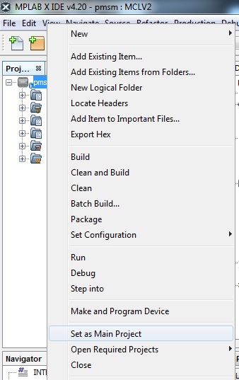

1. Open userparams.h (under pmsm.X -> headerfiles) in the project pmsm.X

* Ensure that TUNING, OPEN_LOOP_FUNCTIONING, and TORQUE_MODE are not defined.
* if demonstration is for Internal Op Amp configuration then define INTERNAL_OPAMP_PIM.

1. Open pim_select.h (under pmsm.X -> headerfiles->hal) in the project pmsm.X and ensure INTERNAL_OPAMP_PIM is defined as this demonstration is for Internal Op Amp configuration.

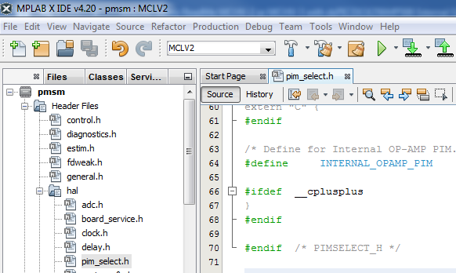

1. Open userparams.h (under pmsm.X -> headerfiles) in the project pmsm.X and ensure SINGLE_SHUNT is defined as this demonstration is for single shunt configuration. undef SINGLE_SHUNT to work with dual shunt configuration.

1. Right click on the project *pmsm.X* and select “Properties” to open its Project Properties Dialog. Click the “Conf: [MCLV2]” category to reveal the general project configuration information.

In the *‘****Conf-MCLV2’*** category window:

* Select the specific Compiler Toolchain from the available list of compilers. Please ensure MPLAB® XC16 Compiler supports the device dsPIC33CK256MP508.In this case “XC16(v1.36)” is selected. The compiler used for testing the firmware is listed in the section 2.2 Software Tools Used for Testing the firmware.
* Select the Hardware Tool to be used for programming and debugging. In this case, “PICkit 4” is the selected programmer.
* 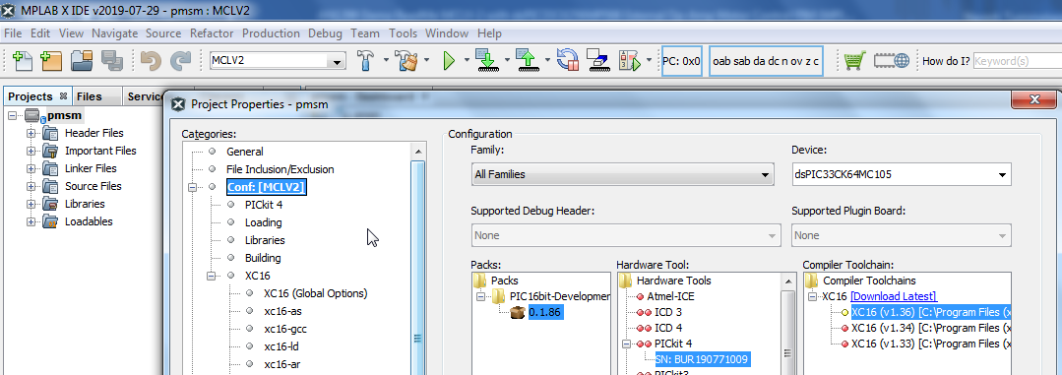After selecting Hardware Tool and Compiler Toolchain, click button **Apply**

1. To build the project (in this case *pmsm.X*) and program the device dsPIC33CK256MP508, click “**Make and Program Device Main project**” on the toolbar.

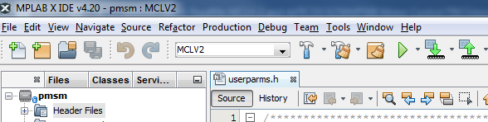

1. If the device is successfully programmed, **LED D2** will be turned ON, indicating that the dsPIC® DSC is enabled.
2. Run or Stop the motor by pressing the push button **S2**. The function of the pushbutton **S2** (Run/Stop of the motor) is indicated by turning ON or OFF the **LED D17**.

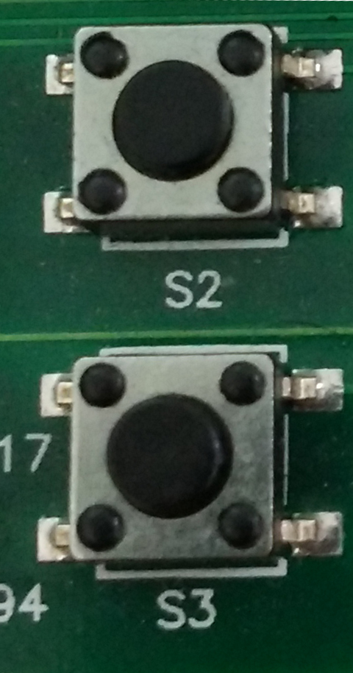

1. If desired, the motor speed can be varied using the potentiometer (labeled “POT1”).

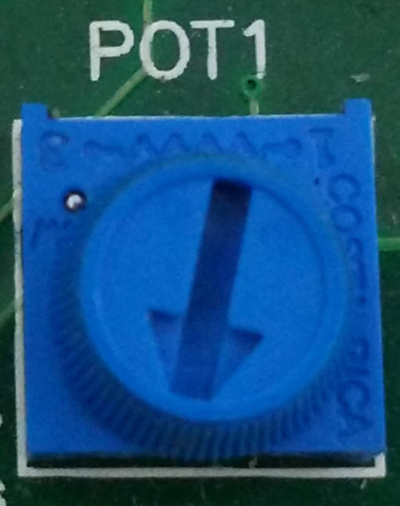

1. To enter the extended speed range (NOMINAL_SPEED_RPM to MAXIMUM_SPEED_RPM) press the push button **S3**. Press the push button **S3** again to revert the speed of the motor to its normal speed (END_SPEED_RPM to NOMINAL_SPEED_RPM) range.
2. Press the push button **S2** to stop the motor.

**Note:**

The macro definitions END_SPEED_RPM, NOMINAL_SPEED_RPM, and MAXIMUM_SPEED_RPM are specified in userparms.h file included in the project *pmsm.X*. The definitions NOMINAL_SPEED_RPM, and MAXIMUM_SPEED_RPM are defined as per the specification provided by the Motor manufacturer. *Exceeding manufacture specification may lead to damage of the motor or(and) the board.*

* 1. Data visualization through X2CScope Plug-in of MPLABX

The application firmware comes with initialization required to interface Controller with Host PC to enable Data visualization through X2C Scope plug-in. X2C-Scope is a third-party plugin for MPLAB X which facilitates real-time diagnostics.

1. Ensure X2C Scope Plug-in is installed. For additional information on how to set up a plug-in refer to <https://microchipdeveloper.com/mplabx:tools-plugins-available>
2. To utilize X2C communication for this demonstration, a mini-USB connection is required between Host PC and dsPICDEM™ MCLV-2 Development Board. Connect a mini-USB cable from your computer to the J8 connector of the dsPICDEM™ MCLV-2 Development Board.
3. Ensure application is configured and running as described under Section Basic Demonstration by following steps 1 through 12.
4. 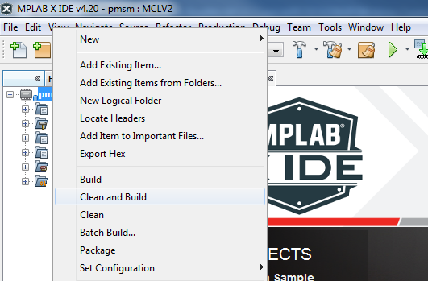Build the project *pmsm.X*. To do that right click on the project *pmsm.X* and select “Clean and Build”.
5. 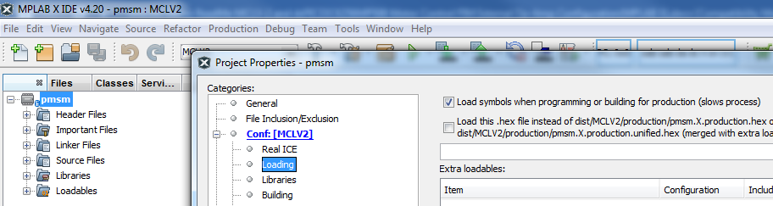Please ensure that the checkbox “Load symbols when programming or building for production (slows process)” is checked, which is under the “Loading” category of the Project Properties window.
6. To build the project (in this case *pmsm.X*) and program the device dsPIC33CK64C105, click “**Make and Program Device Main project**” on the toolbar.



1. Open the X2C window by selecting Tools>Embedded>X2CScope.

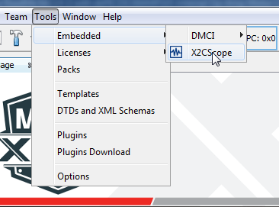

1. In the X2CScope Configuration window, using “Select project” menu, select pmsm.X project as shown.

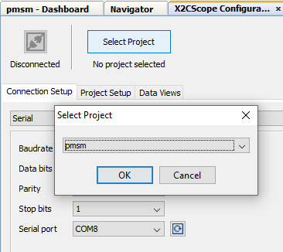

1. Remote Communication needs to be established, as indicated in the following figure. Ensure the communication baud rate is set to 115200 as the same is set in the application firmware, while COM port used depends on the system settings. Refresh button lists the available COM Ports. Select the COM Port as per the connection.

1. Once COM port is detected, click on “**Disconnected**”, and it will turn to “**Connected**”, if the link is established as programmed.

1. Set the “Project Setup” as shown below and click “Set Values”. Set Scope sample time as interval at which X2CScopeUpdate() is called. In this application it is every 20kHz (50µs).

1. When the setup is established, click on open scope View (under sub window “Data Views”), this open Scope Window.

1. In this window, select the variables that needs to be monitored. To do this, click on the source against each channel, a window Select Variables opens upon the screen. From the available list, the required variable can be chosen. Ensure check boxes Enable & Visible are checked for the variables to be plotted.

To view data plots continuously, uncheck Single-shot. When Single-shot is checked it captures the data once and stops. The Sample time factor value multiplied with Sample time determines the time difference between any two consecutive data points on the plot.

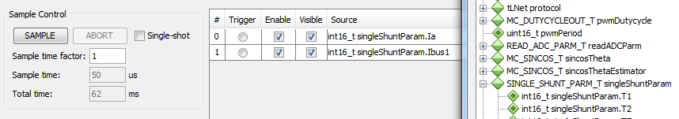

1. Click on SAMPLE, then X2C scope window shows variables in real time, which is updated automatically.

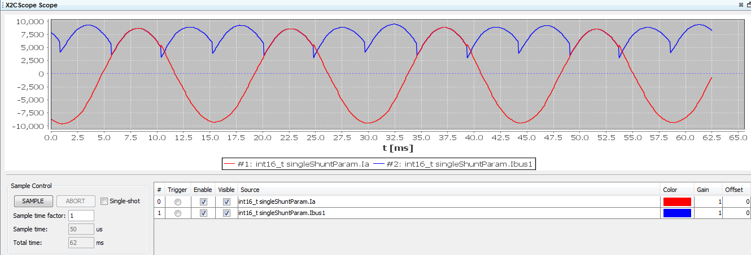

1. Click on ABORT to stop.

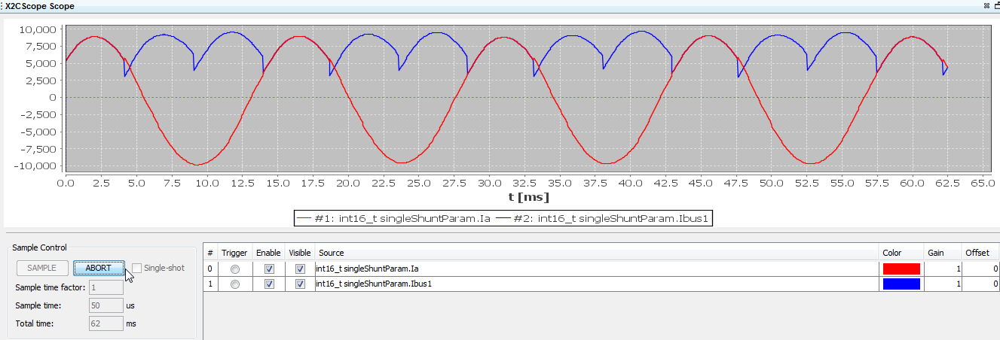

1. dsPIC® DSC RESOURCE USAGE SUMMARY
   1. Device Pin Mapping and Its Functionality in the Firmware:

The following table summarizes device pins configured and used in the AN1299 motor control application firmware demonstrated using the Development Board and the dsPIC33CK256MP508 Internal Op Amp Motor Control PIM (MA330051-2). Refer “*dsPIC33CK256MP508 Internal Op Amp Motor Control Plug-in-Module (PIM) Information Sheet”* for more information.

|  |  |  |  |  |  |
| --- | --- | --- | --- | --- | --- |
| Functional Description | PIM PIN Number | Device PIN Number | Device Pin Name | Signal Type | Remarks |
| **Motor Control PWMs and Fault Input** | | | | | |
| PWM1H | PIM:94 | 1 | RP46/**PWM1H**/**RB14** | PWM  Output | Controls  Hex Bridge MOSFET Q5 |
| PWM1L | PIM:93 | 3 | RP47/**PWM1L** /**RB15** | PWM  Output | Controls  Hex Bridge MOSFET Q6 |
| PWM2H | PIM:99 | 47 | TDI/RP44/**PWM2H** /**RB12** | PWM  Output | Controls  Hex Bridge MOSFET Q3 |
| PWM2L | PIM:98 | 48 | RP45/**PWM2L** /**RB13** | PWM  Output | Controls  Hex Bridge MOSFET Q4 |
| PWM3H | PIM:03 | 45 | TMS/RP42/**PWM3H** /**RB10** | PWM  Output | Controls  Hex Bridge MOSFET Q1 |
| PWM3L | PIM:100 | 46 | TCK/RP43/**PWM3L** /**RB11** | PWM  Output | Controls  Hex Bridge MOSFET Q2 |
| FAULT_MC | PIM:18 | 30 | RP72/**PCI19**/**RD8** | PWM  Input | Connected to  Over Current Fault Output |
| **Analog Inputs – Phase Currents, Speed Reference** | | | | | |
| POT | PIM:32 | 20 | **AN15**/IBIAS2/RP51/**RC3** | Analog Input | Speed Reference  Connected to Potentiometer POT1 |
| IA+ | PIM:74 | 10 | **OA1IN+**/AN9/RA2 | Analog Input | Op Amp 1 Non Inverting Input (Internal to dsPIC33CK256MP508) |
| IBUS+ | PIM:66 | 09 | **OA1IN-**/RA1 | Analog Input | Op Amp 1 Inverting Input (Internal to dsPIC33CK256MP508) |
| IMOTOR1 (Amplified IA) | Not Applicable | 08 | **OA1OUT**/**AN0**/CMP1A/IBIAS0/RA0 | Analog Output | Op Amp 1 Output  (Internally connected to dsPIC33CK256MP508’s ADC) |
| IB+ | PIM:73 | 27 | PGC2/**OA2IN+**/RP36/RB4 | Analog Input | Op Amp 2 Non Inverting Input  (Internal to dsPIC33CK256MP508) |
| IBUS+ | PIM:66 | 26 | PGD2/**OA2IN-**/AN8/RP35/RB3 | Analog Input | Op Amp 2 Inverting Input (Internal to dsPIC33CK256MP508) |
| IMOTOR2 (Amplified IB) | Not Applicable | 25 | **OA2OUT**/**AN1**/AN7/CMP1D/RP34/INT0/RB2 | Analog Output | Op Amp 2 Output  (Internally connected to dsPIC33CK256MP508’s ADC) |
| IBUS+ | PIM:66 | 16 | **OA3IN+**/AN14/ISRC1/RP50/RC2 | Analog Input | Op Amp 3 Non Inverting Input  (Internal to dsPIC33CK256MP508) |
| IBUS- | PIM:67 | 15 | **OA3IN-**/AN13/CMP1B/ISRC0/RP49/RC1 | Analog Input | Op Amp 3 Inverting Input (Internal to dsPIC33CK256MP508) |
| IBUS  (Amplified IBUS) | Not Applicable | 12 | **OA3OUT**/**AN4**/IBIAS3/RA4 | Analog Input | Op Amp 3 Output  (Internally connected to dsPIC33CK256MP508’s ADC) |
| **Miscellaneous Signals** | | | | | |
| BTN_1 | PIM:83 | 41 | RP59/**RC11** | Digital  Input | Connected to Push Button S2 |
| BTN_2 | PIM:84 | 38 | RP52 /**RC4** | Digital Input | Connected to Push Button S3 |
| Debug LED1 | PIM:60 | 03 | RP60/**RC12** | Digital Output | Connected to LED D17 |
| Debug LED2 | PIM:01 | 04 | RP61/**RC13** | Digital  Output | Connected to LED D2 |
| RX (UART) | PIM:49 | 28 | **RP56**/ASDA1/**RC8** | UART1  Input | Connected to UART-USB converter to establish serial communication interface between Host PC and the dsPIC® DSC as needed by DMCI-RTDM. |
| TX (UART) | PIM:50 | 44 | **RP65/**PWM4H**/RD1** | UART1  Output | Connected to UART-USB converter to establish serial communication interface between Host PC and the dsPIC® DSC as needed by DMCI-RTDM. |

1. REFERENCES:

For additional information, refer following documents or links.

1. AN1292 Application Note “Sensorless Field Oriented Control (FOC) for a Permanent Magnet Synchronous Motor (PMSM) Using a PLL Estimator and Field Weakening (FW)”
2. dsPICDEM™ MCLV-2 Development Board User’s Guide(DS52080)
3. dsPIC33CK256MP508 Internal Op Amp Motor Control Plug-in-Module (PIM) Information Sheet
4. dsPIC33CK256MP508 Family datasheet (DS70005399).
5. Family Reference manuals (FRM) of dsPIC33CK256MP508 family
6. MPLAB® X IDE User’s Guide (DS50002027) or MPLAB® X IDE help
7. [MPLAB® X IDE installation](http://microchipdeveloper.com/mplabx:installation)
8. [MPLAB® XC16 Compiler installation](http://microchipdeveloper.com/xc16:installation)